HAWTHORN MEDICAL CENTRE STATEMENT

We are aware that some patients have questions about the future of Hawthorn Medical Centre and what this means for local services.

We would like to reassure patients that there is no immediate impact on the services provided by the practice, which remains fully open and operational.

Our priority is to ensure continued access to GP services for local people and to minimise any disruption for patients.

A new permanent site on Moseley Road has received planning permission and building works are scheduled to begin later this summer. There will be a need for temporary accommodation from when the lease at the current site ends in December 2026 until the new permanent site is completed in Summer 2027.

The Practice and Walk-in- Centre will be relocated to temporary accommodation in a fully-fitted, accessible building with fit-for-purpose clinical space, to provide the same Primary Care offer that you have now. (Similar to the image below)

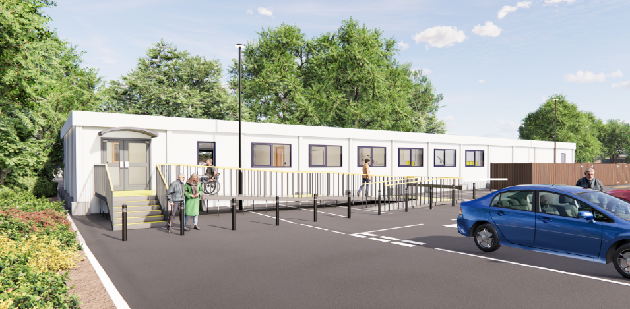
This will be located at:
Asda Longsight
Stanley Grove,
Longsight,
M12 4NH

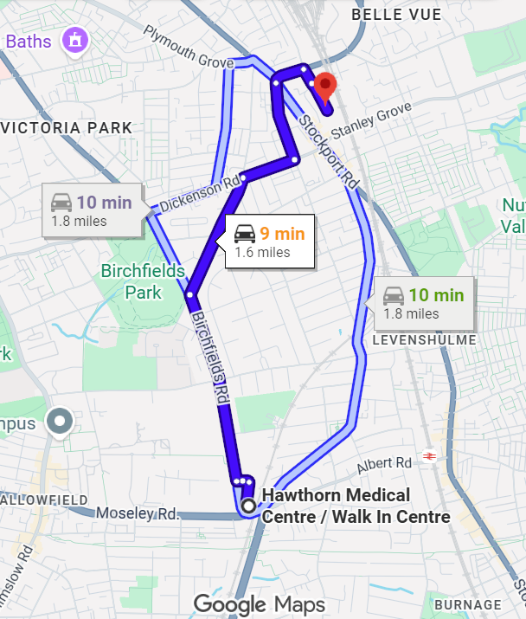
We understand that travelling to a different location may be inconvenient for some patients. The temporary premises have been chosen to ensure we can continue delivering safe, high-quality care while the new building is being developed.
We will create a travel plan to help people plan their journey to the temporary building. Car parking is available on site.

Located 1.1 miles away from the current site, with a driving distance of 1.6 miles

Patients do not need to take any action at this stage and all services will continue as normal.

What is staying the same?
- You will remain registered with the practice.
- Your GP and healthcare team will continue to provide your care.
- Telephone numbers, online services, and the practice website will remain unchanged.
- Appointment booking arrangements will stay the same.
- Prescriptions and routine services will continue as normal.

We acknowledge that this is difficult for patients but this is an important step towards your future Hawthorn Medical Centre which will be built on Moseley Road, less than 100 metres from the current Medical Centre. This will be owned and delivered by the NHS and offer a modern practice building that will provide an improved environment for patients and staff with new larger modern facilities and clinical rooms. Resulting in a wider range of medical services and more training space for staff. The new premises will support the delivery of healthcare services for many years to come

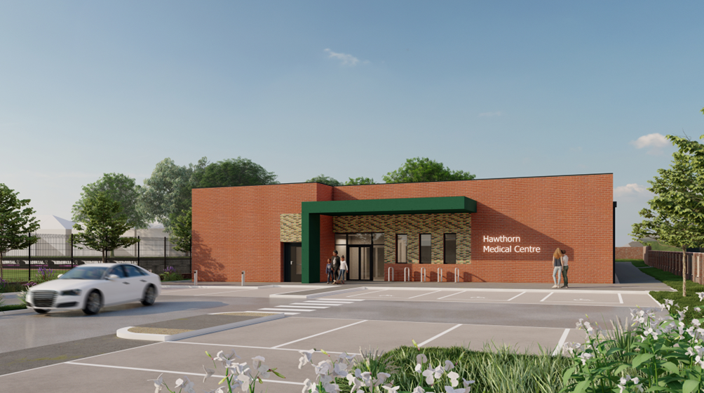

We understand that patients may have questions and we are committed to keeping our community informed. Further updates will be provided as plans progress and more information becomes available including confirming the move-in date for the temporary building.
